Name:________________________________________

Literature Evaluation Planning Sheet 5
Main Idea:

Bulleted List of Support:

ONE idea or concept Explain the importance using evidence

Vocabulary Word | Definition
1.
2.

Nonfiction Structure
Text Features:
1.
How did it help your understanding?
description
sequence & order
compare & contrast
cause & effect
problem & solution

Name:________________________________________

Literature Evaluation Planning Sheet 6
Book1:______________________________________________________
Book2:______________________________________________________

ONE concept found in both texts Explain the importance using evidence from BOTH texts

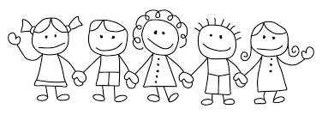
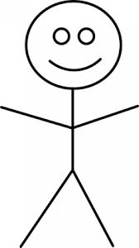
Which text was more helpful?
Author’s use of evidence, Information, and Text Features:

Third Person
First Person

Book 2 Nonfiction Structure
Text Feature found in both texts:

Explain which author used the text feature better:
description
sequence & order
compare & contrast
cause & effect
problem & solution
Book 1 Nonfiction Structure
description
sequence & order
compare & contrast
cause & effect
problem & solution
Name: ________________________________________

Literature Evaluation Planning Sheet 7
Setting:
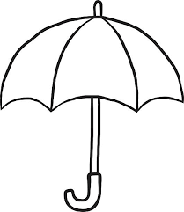

Time:

Time Span:

Place:
Theme
Two Words Related to Event
Third
F
Point of View
First

Why do you think the author included this character in the story?

Connection to Historical Event:
Evidence:
List of Events from Story:
Purpose of Minor Character
Name:________________________________________

Literature Evaluation Planning Sheet 8
Lesson Learned (Theme):

Famous Quote:

Beginning:
End:

Middle:

THREE ideas or concepts

Vocabulary Word | Definition
1.
2.

Nonfiction Structure
Text Features:
1.
2.
3.
description
sequence & order
compare & contrast
cause & effect
problem & solution

Name:________________________________________

Nonfiction Share
Main Idea:

Detail:

Detail:

Detail:
Detail:

THREE ideas or concepts

Vocabulary Word | Definition
1.
2.
3.

Nonfiction Structure
Text Features:
1.
2.
3.
description
sequence & order
compare & contrast
cause & effect
problem & solution

